Stock # Ontario

Notification of Vehicle Brand

HOLDER OF VEHICLE PORTION OF THE PERMIT
Surname, Given Names  FORMTEXT , |  |  |  |  |  |  |  |  |  |  |  |  |  |  |  |  |  |  |  |  |  | Driver’s Licence Number/RIN (Registered Identification Number)
Street, P.O. Box Number |  |  |  |  |  |  |  |  |  |  |  |  |  |  |  |  |  |  |  |  |  | City, Town or Village / Province
Postal Code |  |  |  |  |  |  |  |  |  |  |  |  |  |  |  |  |  |  |  |  |  | Telephone Number
REGISTERED PLATE OWNER (Complete If Different From Vehicle Owner)
Surname, Given Names  , |  |  |  |  |  |  |  |  |  |  |  |  |  |  |  |  |  |  |  |  |  | Driver’s Licence Number/RIN Registered Identification Number)
Street, P.O. Box Number |  |  |  |  |  |  |  |  |  |  |  |  |  |  |  |  |  |  |  |  |  | City, Town, Village / Province
Postal Code |  |  |  |  |  |  |  |  |  |  |  |  |  |  |  |  |  |  |  |  |  | Telephone Number

VEHICLE INSURANCE
Insurance Company/Insurer |  |  |  |  |  |  |  |  |  |  |  |  |  |  |  |  |  |  |  |  |  | RIN (Registered Identification Number)
Street, P.O. Box Number |  |  |  |  |  |  |  |  |  |  |  |  |  |  |  |  |  |  |  |  |  | City, Town or Village / Province
Telephone Number |  |  |  |  |  |  | Fax Number |  |  |  |  |  |  |  |  |  |  |  |  |  |  |  |  |  | Postal Code
Policy Number |  |  |  |  |  |  | Claim Number |  |  |  |  |  |  |  |  |  |  |  |  |  |  |  |  |  | Claim Representative
Date of Incident |  |  |  | DD/MM/YY |  |  |  |  |  |  |  | Date of Settlement |  |  |  |  |  |  |  | DD/MM/YY |  |  |  |  |  |  |  |  |  | Date of Acquired Ownership |  |  |  |  |  |  |  |  | DD/MM/YY

VEHICLE INFORMATION
Vehicle Identification Number (V.I.N.) – type or print clearly
Make |  |  |  |  |  | Model |  |  |  |  |  |  |  |  |  |  |  |  | Year |  |  |  |  |  |  |  | Type (Truck, Bus, Auto, etc.)  CAR |  |  |  |  |  |  | Vehicle Permit Number
Colour |  |  | Odometer |  |  |  |  |  |  | Km |  |  | Mi |  | Licence Plate |  |  |  |  |  |  |  | Prov./State  ON |  |  |  |  | 2 Door |  |  |  |  | 4 Door |  |  |  |  | Convertible

APPRAISAL / INSPECTION CONTACT PERSON
Name of Appraiser/Person who carried out inspection |  |  |  |  |  |  |  |  |  |  |  |  |  |  |  |  |  |  |  |  | Appraisal Company/MVIS Licencee, If Applicable
Street, P.O. Box Number |  |  |  |  |  |  |  |  |  |  |  |  |  |  |  |  |  |  |  |  |  |  |  |  |  | Inspector Trade Code, If Applicable
City, Town or Village |  |  |  |  |  |  |  |  |  |  |  |  |  |  |  |  |  |  |  |  |  |  |  |  |  | MVIS Licencee No., If Applicable
Postal Code |  |  |  |  |  |  |  |  | Telephone Number |  |  |  |  |  |  |  |  |  |  |  | Date Ownership Assumed  Or Date of Settlement – earliest date |  |  |  |  |  |  |  |  |  |  |  |  |  | DD/MM/YY

BRAND DETERMINATION
Total Loss By: |  |  |  |  |  |  |  | Theft |  |  |  |  |  |  |  |  |  |  |  |  |  |  |  | Fire |  |  |  |  |  |  | Other |  |  |  |  | Specify
 |  |  |  |  |  |  |  | Collision / PD |  |  |  |  |  |  |  |  |  |  |  |  |  |  |  | Flood
Brand |  | None |  |  |  |  |  |  | Salvage |  |  |  |  |  |  |  | Irreparable |  |  |  |  |  |  |  |  |  |  |  | Owner Retained Salvage |  |  |  |  |  |  |  | Stolen / Unrecovered
Construction Type |  |  |  |  |  |  |  |  |  |  |  |  |  | Unibody |  |  |  |  |  |  |  |  |  |  |  |  |  |  |  |  |  | Body/Frame
Brand Determination: Mark Damaged Areas |  |  |  |  |  |  |  |  |  |  |  |  |  |  |  |  |  |  |  |  | Part 1 of the Schedule
 |  |  |  |  | Left |  |  |  |  |  |  |  |  |  |  |  |  |  |  |  | Radiator Support Assembly
 |  |  |  |  |  |  |  |  |  |  |  |  |  |  |  |  |  |  |  |  | Upper Rail Assembly – Left
 |  |  |  |  |  |  |  |  |  |  |  |  |  |  |  |  |  |  |  |  | Upper Rail Assembly – Right
Rear |  |  |  |  | 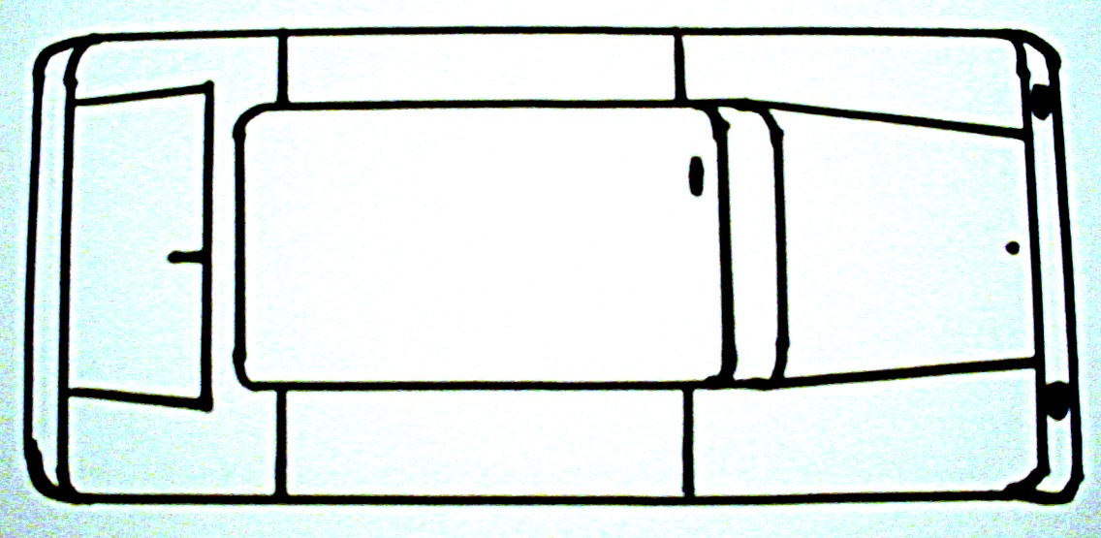 |  |  |  |  |  |  |  |  |  |  | Front |  |  |  |  | Lower Rail Assembly – Left
 |  |  |  |  |  |  |  |  |  |  |  |  |  |  |  |  |  |  |  |  | Lower Rail Assembly – Right
 |  |  |  |  |  |  |  |  |  |  |  |  |  |  |  |  |  |  |  |  | Front Strut Tower / Apron Assembly – Left
 |  |  |  |  | Right |  |  |  |  |  |  |  |  |  |  |  |  |  |  |  | Front Strut Tower / Apron Assembly – Right
 |  |  |  |  |  |  |  |  |  |  |  |  |  |  |  |  |  |  |  |  | Cowl Top Panel Assembly
 |  |  |  |  |  |  |  |  |  |  |  |  |  |  |  |  |  |  |  |  | Engine Sub-frame Assembly
Part 2 of the Schedule |  |  |  |  |  |  |  |  |  |  |  |  |  |  |  |  |  |  |  |  | Part 3 of the Schedule
Dash Panel Assembly |  |  |  |  |  |  |  |  |  |  |  |  |  |  |  |  |  |  |  |  | Rear Strut Tower / Inner Wheelhouse Assembly - Left
Windshield “A” Pillar Assembly - Left |  |  |  |  |  |  |  |  |  |  |  |  |  |  |  |  |  |  |  |  | Rear Strut Tower / Inner Wheelhouse Assembly – Right
Windshield “A” Pillar Assembly – Right |  |  |  |  |  |  |  |  |  |  |  |  |  |  |  |  |  |  |  |  | Inner Quarter Panel Assembly - Left
Side Rocker Panel Assembly - Left |  |  |  |  |  |  |  |  |  |  |  |  |  |  |  |  |  |  |  |  | Inner Quarter Panel Assembly – Right
Side Rocker Panel Assembly – Right |  |  |  |  |  |  |  |  |  |  |  |  |  |  |  |  |  |  |  |  | Rear End Panel Assembly - Upper
Center Hinge “B” Pillar Assembly - Left |  |  |  |  |  |  |  |  |  |  |  |  |  |  |  |  |  |  |  |  | Rear End Panel Assembly – Lower
Center Hinge “B” Pillar Assembly – Right |  |  |  |  |  |  |  |  |  |  |  |  |  |  |  |  |  |  |  |  | Rear Sub Frame Assembly - Left
Rear “C” Pillar Assembly – Left |  |  |  |  |  |  |  |  |  |  |  |  |  |  |  |  |  |  |  |  | Rear Sub Frame Assembly – Right
Rear “C” Pillar Assembly – Right |  |  |  |  |  |  |  |  |  |  |  |  |  |  |  |  |  |  |  |  | Trunk Floor Pan Assembly
Front Floor Pan Assembly
Rear Floor Pan Assembly
Roof Panel (structural) Assembly
Part 4 of the Schedule |  |  |  |  |  |  |  |  |  |  |  |  |  |  |  |  |  |  |  |  | Appraiser’s Signature
Full Frame Vehicle: Complete Frame Assembly |  |  |  |  |  |  |  |  |  |  |  |  |  |  |  |  |  |  |  |  | Print Name Farnaz kashfirad

DECLARATION
I hereby certify that the information contained in this document is correct and have read and understand the penalties for a false statement, given below:
Print Name Farnaz Kashfirad |  |  |  |  |  |  |  |  |  |  |  |  |  | Signature |  |  |  |  |  |  |  |  |  |  |  |  |  |  |  |  |  | DD/MM/YY  Date
Warning: It is an offence to provide a false statement of this form. The Highway Traffic Act provides for a penalty of up to $500 or a term of imprisonment of up to 30 days, or both, and a person’s licence or permit may be suspended for up to six months.

